October, 2021: Right Trees for the Right Time Online Workshop
Forest Resource Managers, Land Trust Members, & Land Owners
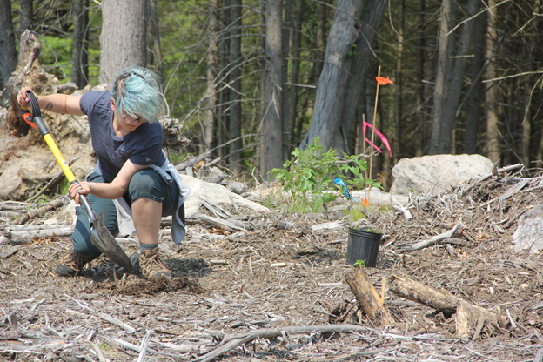 Photo by Judy Benson, CTSG
Gather your team and register!
Focused on New England forests, this October workshop is provided through a Long Island Sound Study Futures Fund Grant led by the University of Connecticut’s Sea Grant program (https://seagrant.uconn.edu/) in collaboration with the Avalonia Land Conservancy (https://avalonia.org/) and the Northern Institute of Applied Climate Science (NIACS https://www.nrs.fs.fed.us/niacs/).
The 4-part program will be virtual, except for one field-based component that can focus a 2-hour trip to a local forest to apply the principles that your team will be learning. The total time commitment will be about 6-8 hours over the month of October.
The 4-part program:
1. October 1, 2021 (Friday) from 1-2:30 PM EST. VIRTUAL, RECORDED
2. October 8, 2021 (Friday) from 1-2:30 EST. A VIRTUAL interactive session
3. Approximately 2 hours for Field Work at a time, date and local forest of your team’s choosing. Alternatively, your team can visit the Hoffman Evergreen Preserve in Stonington, CT on Saturday October 16 from noon to 2 PM with a rain date of Sunday October 17.
4. October 22, 2021 (Friday) from 1 – 2:30 EST. A VIRTUAL interactive session
This Workshop is offered at no cost, but please gather a core team of participants (2-4) who can participate in all four sessions of the workshop. If you cannot raise a team, but wish to participate individually, we can accommodate you if you can commit to the four workshop sessions.

Please click on links below:
Workshop Information
Workshop Registration

This workshop builds on the information presented in the 4-part UConn CLEAR webinar series, Finding the Right Trees for the Right Time. (See archived webinars.) However, you do not need to have listened in on webinars to participate in the workshop.

You can read more about the Hoffman Evergreen Preserve Project here.

If you have any questions, please contact Juliana Barrett (CT Sea Grant): Juliana.barrett@uconn.edu or Sharon Lynch (Avalonia Land Conservancy): slynch@gwu.edu

