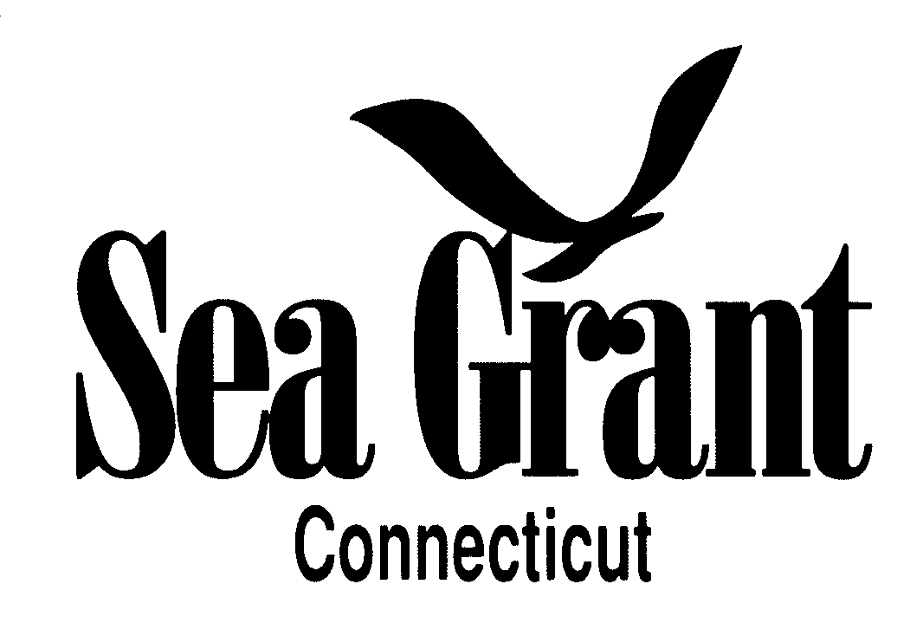

CONNECTICUT SEA GRANT ARTS SUPPORT AWARDS PROGRAM

FOR ARTISTS

Connecticut Sea Grant, through its competitive funding program the Arts Support Awards Program, will award up to $1000 to an artist or group of artists. The winning submission will be selected on the basis of aesthetic quality, relevance to coastal and marine environments and Connecticut Sea Grant themes, as well as its potential impact on non-traditional “audiences.”

Eligibility: Artists or groups of artists who live in Connecticut, or whose work is related to Connecticut’s coastal and marine environments and/or Long Island Sound are eligible for funding consideration. All artistic disciplines are eligible. Previous recipients of Sea Grant Arts Awards are not eligible for five years.

Application Procedure: The application should be submitted electronically as a compiled PDF file with one additional media file (mp3 or mov file), if needed, via email to SeagrantResearch@uconn.edu for receipt no later than 4:30 p.m. ET on Wednesday May 11, 2022. If the proposal or additional media file exceeds 3 MB, provide an online link or utilize a dropbox (i.e.; http://dropbox.uconn.edu/dropbox) to transfer the media. Submissions that are not received by the 4:30 p.m. ET deadline will not be considered for funding in this year’s competition.

The application must include the following items:
- completed summary form (available at http://seagrant.uconn.edu/wp-content/uploads/sites/1985/2017/03/artsgrant-summary-form.docx)
- maximum two-page statement outlining:
  - the objectives of the proposal
  - the relevance of the proposed work to marine environments and Connecticut Sea Grant’s mission
  - specific plans for performing or exhibiting the work(s)
  - plans to reach a large, diverse or non-traditional audience with message(s) compatible with Sea Grant outreach efforts
- itemized budget (note that funds may NOT be used to pay salaries or travel costs, see details below under Terms of Award)
- budget explanation describing the proposed use of the funds
- 1-to-2-page resume or summary of exhibition history and professional credentials
- digital portfolio composed of a representation or outline of the proposed new work, in addition to previous works, containing image, video, text or audio files. See WORK SAMPLE REQUIREMENTS below for detailed guidelines.

Note that the summary form, budget, budget explanation, resume and digital portfolio are NOT included in the two-page limit. Please submit all required documents and do NOT include additional support materials with your proposal.

Deadlines: Submissions will be accepted at any time up until the deadline for the 2022 funding year which is Wednesday May 11, 2022. Applicants will be notified of funding decisions by June 24, 2022.

Evaluation Procedure: Submissions will be reviewed by an independent review panel convened by Connecticut Sea Grant that includes arts professionals.

Criteria for Selection: Submissions will be judged using three criteria: 1. Relevance to CTSG’s mission as outlined in the Connecticut Sea Grant Strategic Plan (https://seagrant.uconn.edu/wp-content/uploads/sites/1985/2020/11/CTSG-strategic-plan-2018-2023-final_optimized.pdf); 2. Aesthetic quality/merit; and 3. other relevant factors including ability to reach or expand non-traditional audience, new works produced and displayed, number of art exhibitions planned, etc. Each submission will be judged using a scale ranging from 1 to 3, where 3=excellent; 2= good; 1=fair. The three criteria scores will be summed for an aggregate total score which will range from 3 to 9, where 3 = fair and 9= excellent. The final award decision will be made by the CTSG Director based on the recommendation of the review panel.

Terms of Award: These funds may be used to pay for supplies and other costs associated with producing works of art, exclusive of payment of salary and travel. The funds must be used within one year of receiving the award. Supported artists are asked to give permission to Connecticut Sea Grant to use images representing the work in promoting the Arts Support Awards Program’s accomplishments. A written report of the results of creative activities supported by Sea Grant, including visual documentation of the artistic pieces and other outcomes, is required at the conclusion of the project. Projects are expected to be completed within 12 months of funding and recipient(s) are required to provide a final report at the end of the project. Recipient(s) are expected to interface with the Connecticut Sea Grant Communications office while implementing funded projects. They should also acknowledge the support of Connecticut Sea Grant in any publicity or printed matter associated with the art developed from this award, and work with the communications office to obtain the Connecticut Sea Grant logo, which should be displayed in advertising associated with any public showings and in funding acknowledgments. Connecticut Sea Grant requests notification of all exhibitions displaying artworks funded under the award. If possible, funded artists are asked to arrange a showing of their completed work at the Alexey Von Schlippe Art Gallery at the Avery Point campus of UConn.

WORK SAMPLE REQUIREMENTS
WRITERS: Writing samples should be representative of the genre in which you propose to work. Works-in-progress may be submitted but should be accompanied by a sample of your finished work. Submit one digital file in WORD or PDF format containing an outline or portion of the proposed work as well as one of the following: (a) six to 10 poems, or (b) up to two short stories, or (c) the first chapter or 20 pages of a book (do NOT send a complete book), or (d) a script of a complete work.
VISUAL ARTISTS: Submit one digital file in PDF format containing rough sketch(es), model(s) or sample photo(s) of the proposed work as well as digital images of recent work, not to exceed 10 images in total (including both proposed and previous works), and a corresponding sheet listing images by title, medium, size and year work was completed. Please ensure that the images are sized large enough to allow for viewing the details of the works.
COMPOSERS: Submit one digital file in PDF format containing a sample of the proposed work as well as: (a) up to three scores (include your name, duration of composition, and date of composition), and, if available, (b) a corresponding audio file in MP3 format of the works labeled with title and your name.

NEW GENRES (Video, film, installation, performance, conceptual art, interactive multi-media and related work): Submit an outline or sample of the proposed work as well as examples of previous works in the form of one digital file (see details below) or link to a web-site URL of the following: short video (not to exceed six minutes) or series of digital images. This should be accompanied by a WORD or PDF file containing: title, artist name, duration of piece and date as well as a description of no more than one page contextualizing the segment. If submitting your works as a digital file, use PDF or MOV format or file format compatible with Quick Time or Real Player.

For guidance and forms and information, visit these links:
- Information and guidelines on how to submit a proposal.
- Arts Grant Summary Form to download as a pdf.
- Information about previous artists and projects funded.
- Link to a video about the “Crosscurrents” retrospective exhibit of works by artists who received an Arts Support Award
or contact:

Dr. Syma A. Ebbin, Research Coordinator
Connecticut Sea Grant College Program
The University of Connecticut
1080 Shennecossett Road
Groton, CT 06340-6048
Tel. (860) 405-9278; FAX: (860) 405-9109

E-mail: syma.ebbin@uconn.edu

