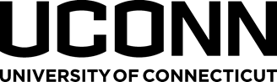

**8th ANNUAL CONNECTICUT SEAWEED STAKEHOLDER WORKSHOP**

Thursday, September 27, 2023

Time: 10am to 2pm

Jones Auditorium

Connecticut Agricultural Experiment Station

123 Huntington St, New Haven, CT 06511

**TENTATIVE Agenda**

1. Welcome and Introductions
2. Regulatory Updates
   1. CT Department of Agriculture Bureau of Aquaculture
   2. US Army Corps of Engineers
   3. CT DEEP
   4. CT Department of Consumer Protection, Food and Standards Division
3. Industry Updates

**Lunch PROVIDed (12pm to 12:40pm)**

1. Guest speaker: Carl Jorgensen, Plant Based Foods Institute (speaker bio included in email)
2. Other topics and Discussion

***\*PLEASE REGISTER BY SEPTEMBER 18TH, 2023 using the link below:*** [***https://form.jotform.com/222223454211138***](https://form.jotform.com/222223454211138)***.***

***We can only guarantee lunch for those who register by the deadline.***